

**IE 492-PROJECT PROPOSAL**

Electricity Market Clearing Price Forecasting

**Advisor:** Mustafa Gökçe Baydoğan

**Group Members:**

Süheyla ŞEKER – 2016402132

Alican YILMAZ – 2016402093

Fatma Nur DUMLUPINAR – 2016402150

**Problem Definition**

Electricity is characteristically a non-storable commodity and has to be accessible constantly. Consequently, unlike other products, it is not possible, under normal operating conditions, to keep it in stock, ration it or have customers queue for it. Furthermore, demand and supply vary continuously. Since it is non-storable, production and consumption should always be equal to each other in order to maximize the well-being of consumers and producers and avoid possible infrastructure problems. Electricity consumption depends on some exogenous factors such as weather, special holidays etc. This special characteristic of electricity results in unique price dynamics and attracts many to do research on the electricity price dynamics. Several statistical, multi-agent, computational intelligence models have been developed and analyzed.(Weron)

Electricity market is a special market with their unique property of balancing requirements in the short and long term. Due to its very nature, over-or under-forecasts compared to realized supply and demand are severely punished by the electricity balancing market. At this point, producers and consumers cannot make optimal use of this system since electricity consumption and production forecasts cannot be made full correctly.

In Turkey, the electricity market is managed by EPİAŞ. Comprehensive and accessible data is provided by EPİAŞ, specifically EPİAŞ Transparency Platform. This also gives transparency and equality to all the market participants. In the electricity market, spot prices are determined through intra-day and day-ahead markets. Market participants offer their bids including **price and quantity** (p,q) to buy or sell electricity from the day-ahead market **for each hour** of the following day. The Market Clearing Price (MCP) and the traded volume are determined for each hour through matching bids of buyers and sellers.(PricewaterhouseCoopers). In this context, not only demand forecasting of electricity is important, but players also should forecast MCP for the next day as all the costs/profits are based on predetermined MCP. The aim of this project is to understand the dynamics of the Turkish Electricity Market and come up with predictive approaches to forecast next-day MCP.

In this project, some limitations related to the data and the problem may be encountered. One of the possible and important constraints that will arise when deciding on the model is the time limit because the large number of bids every day expands the problem size. Therefore, the time required to achieve the best results will increase. In this case it will be very likely to make a trade-off between good performance and time. In addition, some of the missing parts of the auxiliary data that can be used in the model can prevent implementing time series analysis. Finally, the project's other constraints can stem from the NP hard problem and nonlinear social welfare objective.

**Literature Review**

Bidding price is crucial to optimize the prosperity of both producers and consumers in the electricity market. According to Yan & Chowdhury (“*Mid-term electricity market clearing price forecasting: A hybrid LSSVM*” 1), the most significant aspect in the customized electricity markets is to provide the needed electricity quantity "at the right time", with the correct bidding price, and they also state that market clearing price (MCP) which comes up as a result of the market bidding price, is an estimate of the future price of electricity based on predictions of demand, temperature, sunlight, weather conditions etc.

Since many factors are effective in shaping the market clearing price (MCP), a single forecasting method will not be sufficient to estimate the price at the desired accuracy rate. Due to difficulty and complexity in estimation of MCP, many methods such as time series analysis, ARIMA and regression models, Bayesian and simulation techniques have been studied to most accurately predict MCP. (Georgilakis) For these reasons, modeling consisting of combinations of several forecasting and statistical methods can also be used to predict MCP.

Yan & Chowdhury (“*Mid-term electricity market clearing price forecasting: A hybrid LSSVM*” 1) used a hybrid LSSVM and ARMAX approach to forecast MCP. Then next year, Yan & Chowdhury (“*Mid-term electricity market clearing price forecasting utilizing hybrid support vector”* 1 ) tried to make MCP predictions by using hybrid support vector machine and auto-regressive moving average with external input, and and they noted that from the models they applied, the hybrid SVM and ARMAX prediction model outperformed the hybrid LSSVM and ARMAX model, and the models they applied alone.

In a study that looks at the problem from a mathematical programming perspective, day-ahead combinatorial auction is modeled in which the total surplus of the market is maximized by Derinkuyu et al.. Then they approached the problem with heuristics algorithms which are Tabu Search and Genetic Algorithm, and found that Genetic Algorithm performs better. (Derinkuyu et al.)

R. Weron, trying to classify electricity price models in the literature, summarized them as 5 main approaches: Multi-agent models, Fundamental methods, Reduced-form models, Statistical approaches, Computational intelligence techniques.(Weron)

**Project Timeline**

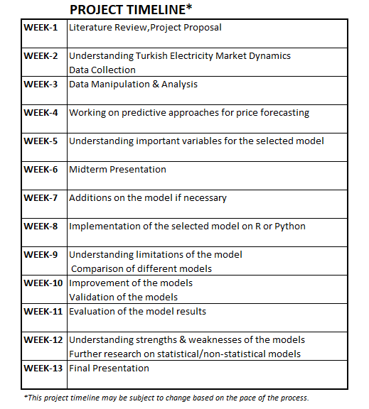

**References**

Georgilakis, Pavlos S. *Market Clearing Price Forecasting in Deregulated Electricity Markets Using Adaptively Trained Neural Networks* . 2006, link.springer.com/chapter/10.1007/11752912_8.

PricewaterhouseCoopers. *Overview of the Turkish Electricity Market*. www.pwc.com.tr/overview-of-the-turkish-electricity-market.

Weron, Rafał. *Electricity Price Forecasting: A Review of the State-of-the-Art with a Look into the Future*. 18 Sept. 2014, www.sciencedirect.com/science/article/pii/S0169207014001083.

Yan, Xing, and Nurul A. Chowdhury. *Mid-Term Electricity Market Clearing PRICE Forecasting: A Hybrid LSSVM AND ARMAX APPROACH*. 30 Apr. 2013, [www.sciencedirect.com/science/article/pii/S0142061513001658](http://www.sciencedirect.com/science/article/pii/S0142061513001658).

Yan, Xing, and Nurul A. Chowdhury. “Mid-Term Electricity Market Clearing Price Forecasting Utilizing Hybrid Support Vector Machine and Auto-Regressive Moving Average with External Input.” *International Journal of Electrical Power & Energy Systems*, vol. 63, 2014, pp. 64–70., doi:10.1016/j.ijepes.2014.05.037.

Derinkuyu, Kursad, et al. *Optimizing Day-Ahead Electricity Market Prices: Increasing the Total Surplus for Energy Exchange Istanbul*. 5 Nov. 2019, pubsonline.informs.org/doi/10.1287/msom.2018.0767.

Weron, Rafał. *Electricity Price Forecasting: A Review of the State-of-the-Art with a Look into the Future*. 18 Sept. 2014, www.sciencedirect.com/science/article/pii/S0169207014001083.